**ACTIVITY-2**

**Deploy a simple application on the cloud / Deploy one simple web app on a web server using a cloud platform**

* Download any .exe file(software) from the following website

https://mega.nz/file/hYYyEKaJ#qXH6uiKTJ1P-Gjh8IRolASaOMTO5qABZT_oTog1q1ms

Create a Mega account from the following website [/https://mega.nz/registe](http://https:/mega.nz/registe)

* **Upload the Downloaded .exe file to the cloud**

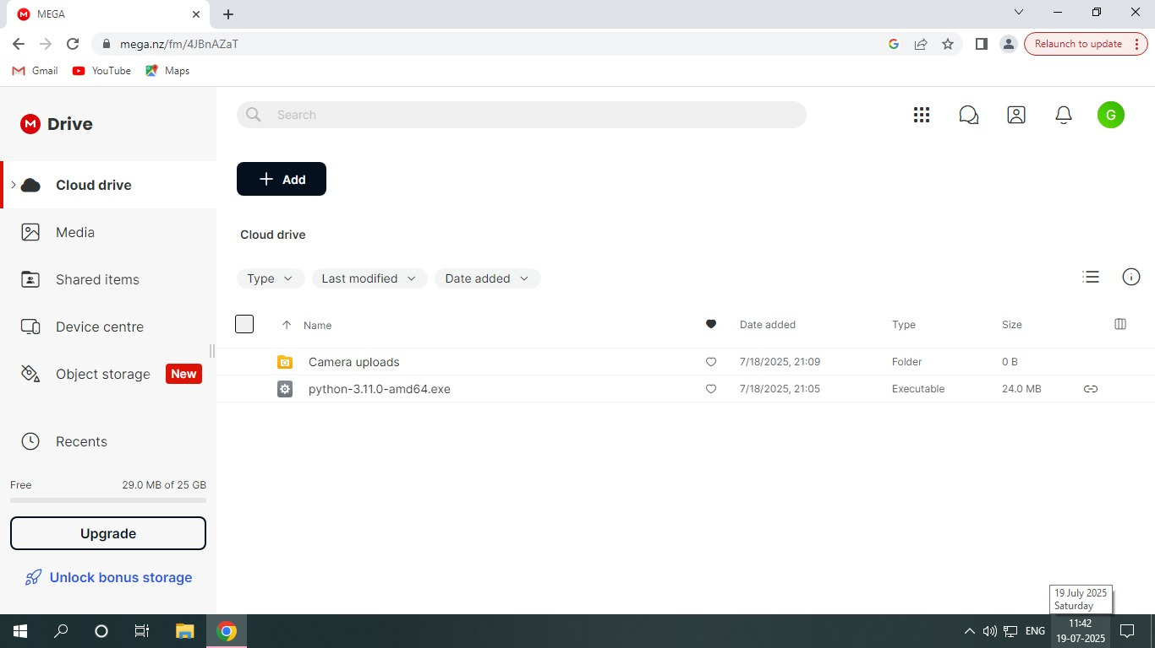

* **Design a simple web page using HTML**

‎<!DOCTYPE html>

‎<html>

‎ <head>

‎ <title>HTML Image as link</title>

‎ </head>

‎ <body>

‎Python(3.11.0) download:<br>

<a href="https://mega.nz/file/IB5ERLwS#VucIPZLFtqmRYUaABczBsw3zJC8L5HGDRGH

W1mzDVBw">

‎ <img src="/storage/emulated/0/Download/python3.11.0amd64.exe"width="800"

height="500">

‎</a>

‎</body>

‎ </html>

‎

* **Download a python image and locate the Folder path and copy it to img src in the HTML code.**

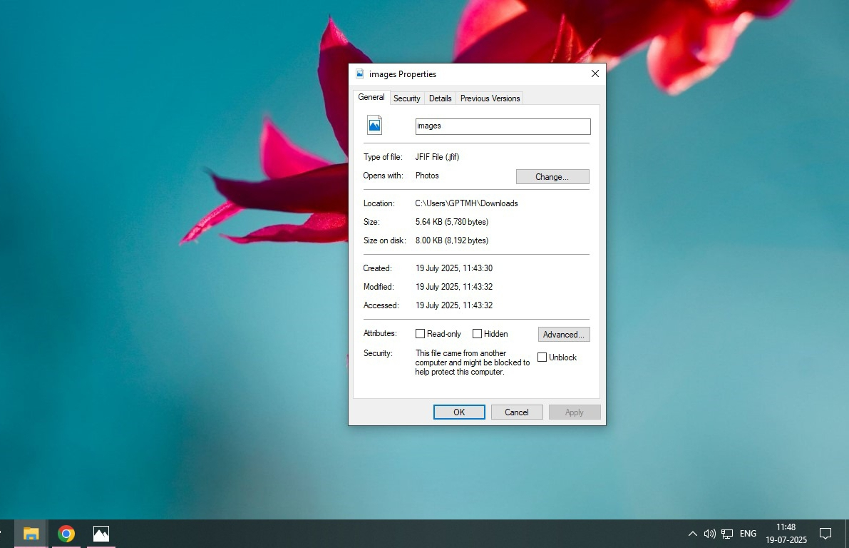

* **Now change the href link in your code using the link of the.exe file that you have 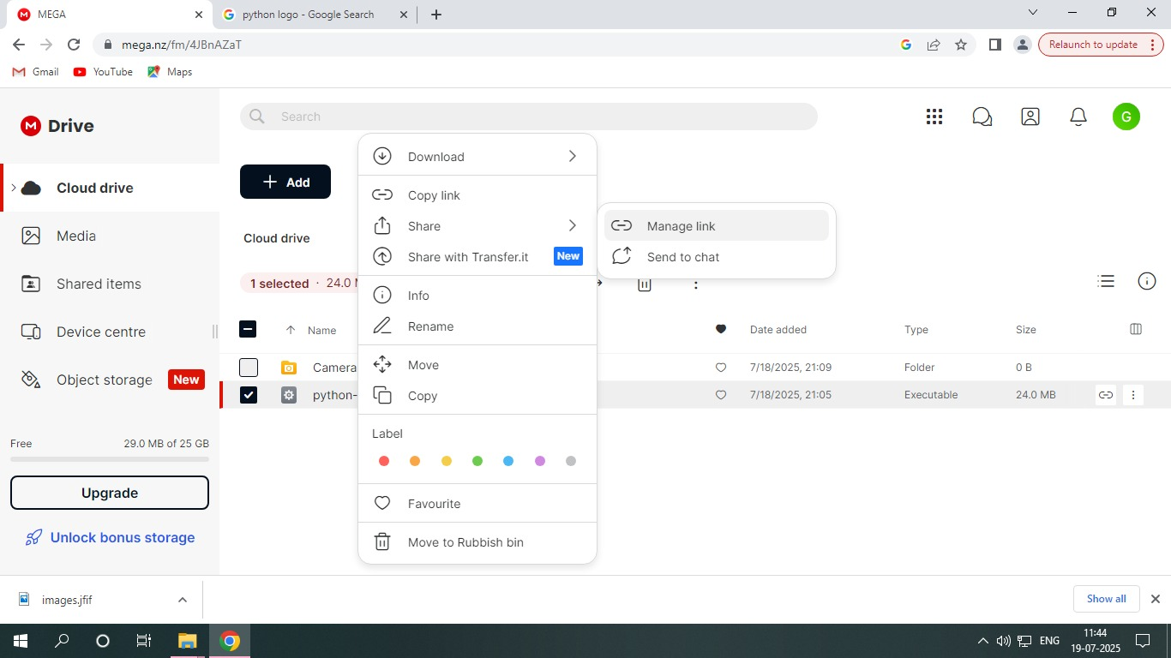uploaded in the cloud.**

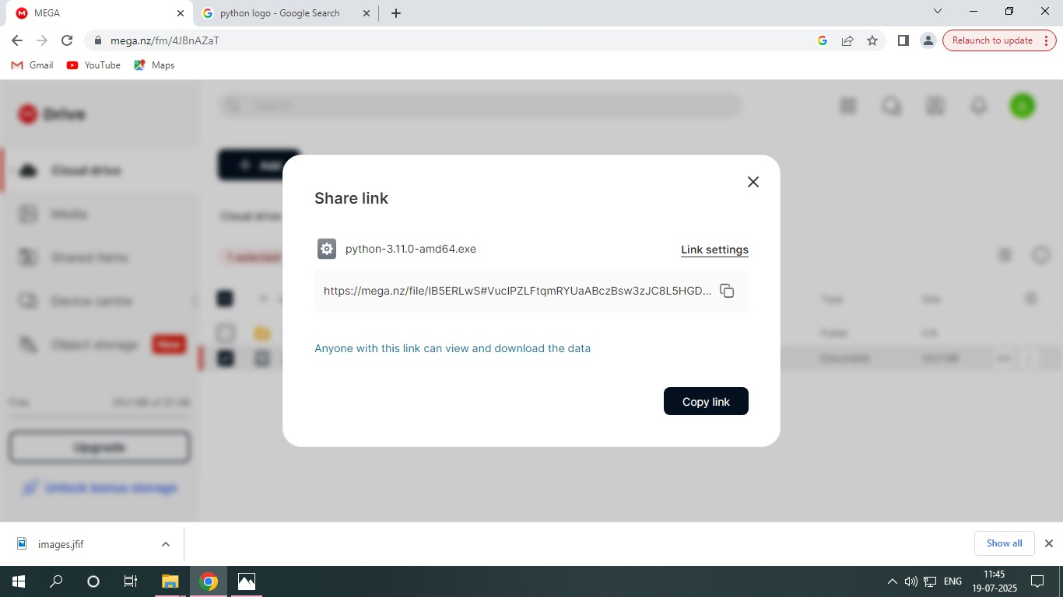

* **Now save the file in .html extension and open it using any web browser.**

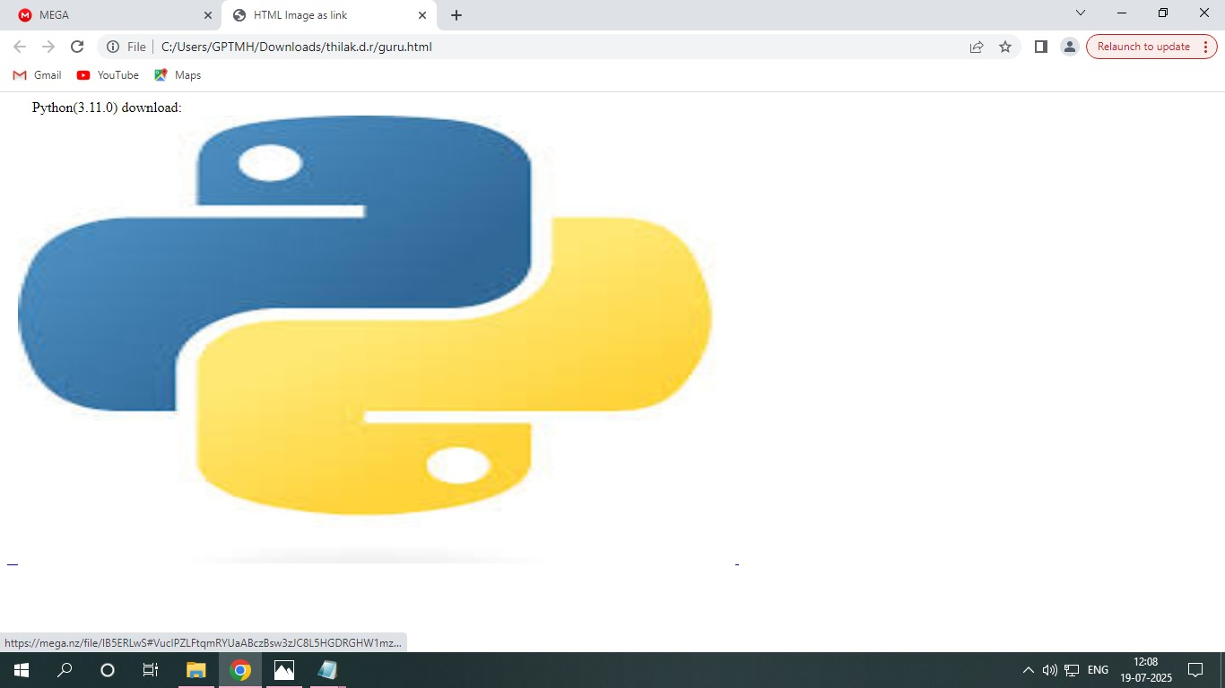

* **Click on the python image and it will redirect the page to cloud storage where you have uploaded your .exe file.**

